STEP 1-Set up configure github account

-Enter all your details

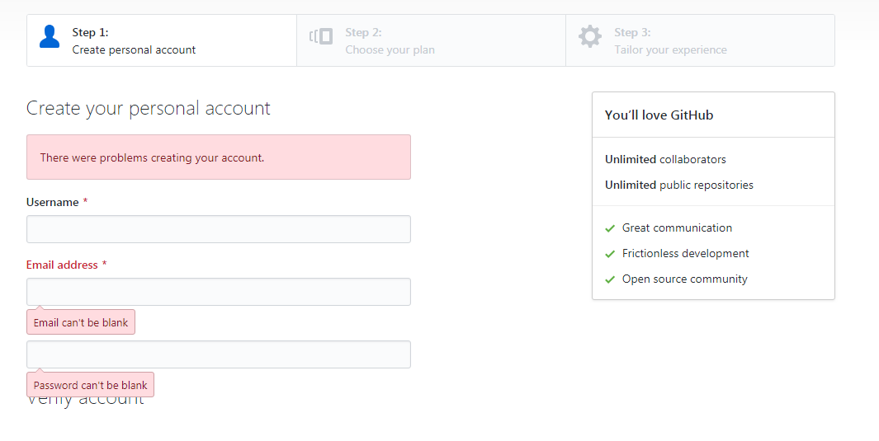

Step2-You can create ssh-key via **Git bash** by following the steps:

* Open your **Git bash**

Execute the command: ssh-keygen -t rsa -b 4096 -C “<your email address>” 🡪 press [enter]

Step3-Login and connect with remote git with local Git



Step4-Create repo in GITHUB

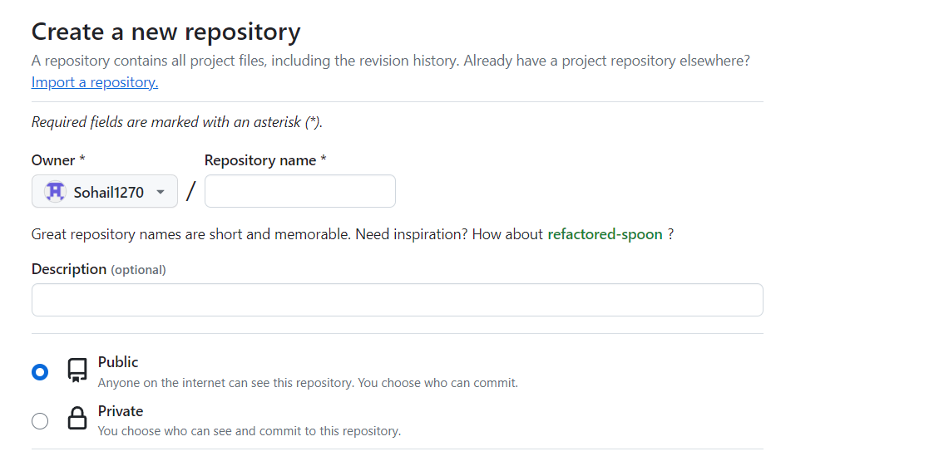

Step5-Copy SSH or HTTP KEY

